Local Thriving Communities
Action Plan 2022-24
Building capacity through existing
service delivery mechanisms

Acknowledgement
We pay respect to the spirit of Country which continues to nurture us all. We acknowledge all First Nations groups across Country, for their traditional law, customs, and custodianship responsibilities to the land, sea and waters, and the cultural knowledge holders who maintain these responsibilities, past, present, and emerging.
We recognise it is our collective efforts and responsibility as individuals, communities, and governments to ensure equality, recognition, and advancement of Aboriginal and Torres Strait Islander Queenslanders across all aspects of society and everyday life.
On behalf of the Queensland Government, we offer a genuine commitment to fearlessly represent, advocate for, and promote the needs of Aboriginal and Torres Strait Islander Queenslanders with unwavering determination, passion, and persistence.
As we reflect on the past and give hope for the future, we walk together on our shared journey to reconciliation where all Queenslanders are equal.
Statement on the use of terms
We recognise that Aboriginal people and Torres Strait Islander people each have their own unique languages, beliefs, cultural practices, traditions, and diversity within each culture. This document includes a range of collective terms to reference and reflect the unique identity of Aboriginal people and Torres Strait Islander people. The primary term that has been used is Aboriginal people and Torres Strait Islander people, with other terms used including First Nations peoples.

Contents
Acknowledgement 2
Message from the Queensland Government 4
Statement by the Joint Coordinating Committee (JCC) community representatives 5
Glossary 6
Introduction 8
Snapshot – LTC Action Plan 2022-2024 9
Vision 9
Target 9
Key Priority Areas 10
Implementation so far 11
By the end of 2024 11
Community perspective of LTC 12
Taking Action – the key priority areas 14
Priority Area 1 - Investment Mapping 15
Priority Area 2 - Data Sharing and Monitoring and Evaluation 18
Priority Area 3 - Standing up Local Decision Making Bodies 21
Priority Area 4 - Whole-of-government capacity building 25
Priority Area 5 - Mapping existing legislative and procurement frameworks 28
Local Thriving Communities Governance 31
Addendum: Pathway to Local Decision Making 34

Editorial note: Messages from the Queensland Government and Community Representatives appear side-by-side demonstrating the partnership approach to progressing the Local Thriving Communities reform.

Message from the Queensland Government
We are pleased to present the inaugural Local Thriving Communities Action Plan. Progressing local solutions and decision-making with Aboriginal people and Torres Strait Islander people is critical for communities to thrive.
The Queensland Government is reframing the relationship with First Nations peoples in ways that acknowledges, embraces, and celebrates First Nations peoples’ universal humanity. This reframed relationship is key to enabling transformational change built on collaborative co-design of local strategies. The Local Thriving Communities Joint Coordinating Committee (JCC) was established in April 2019 to provide advice to government about co-design and implementation of the Local Thriving Communities reform. The JCC is a key governance mechanism driving the reform process and bringing a high-level of cultural intelligence to this work.
This approach recognises that systemic reform requires comprehensive collaboration and strong partnerships to support the conditions for community-led change. With First Nations people leading the way, Local Thriving Communities embodies principles of self-determination, local decision-making, and high-expectations relationships to co-design solutions to achieving community aspirations. This Action Plan sets out workable solutions to be implemented in the short term, focusing on both government and community readiness initiatives to support working together within a reframed way. These solutions have been identified through extensive consultation with community and government stakeholders, including leaders with cultural authority, members of the JCC and government committees, bringing together cultural and government expertise.
Publishing this Action Plan ratifies the transparent and accountable approach to the reform, while leveraging both community and government expertise in all aspects of design and delivery of services and systems, including local housing plans, health equity strategies and education. By embracing existing strengths in leadership and building capacity at the local level, Local Thriving Communities contributes to building an enabling environment in Queensland’s communities for future engagement to support reform processes. The Local Thriving Communities Action Plan sets a strong and innovative approach to reforming how government works with Aboriginal people and Torres Strait Islander people in Queensland to enable communities to thrive.
We commend the JCC on the excellent achievements to date and look forward to continuing to take strides towards a new and thriving future for Queensland communities, together.

The Honourable Craig Crawford MP
Minister for Seniors and Disability Services and Minister for Aboriginal and Torres Strait Islander Partnerships

Dr Chris Sarra
Director-General
Department of Seniors, Disability Services and Aboriginal and Torres Strait Islander Partnerships

Statement by the Joint Coordinating Committee (JCC) community representatives
We, the JCC community representatives, are working with the Queensland Government to improve outcomes for Aboriginal people and Torres Strait Islander people under the Local Thriving Communities reform. Our role is to provide considered advice informed by our experience in community and cultural intelligence. During the last two years, we have partnered alongside government in organising for this new way and in supporting community groundwork.
Reform work is long and detailed, and we commend First Nations people and communities for setting this reform agenda with government. Developing the systems and architecture to support such change requires significant expertise from all parties, and we are proud to have been working beside the Queensland Government providing oversight, guidance and advocating for the best outcomes for Aboriginal and Torres Strait Islander communities.
The Local Thriving Communities Action Plan is a milestone in Queensland’s progress of the Local Thriving Communities reform. It sets a pathway to support government readiness and will enable communities to develop in a responsible, sustainable, and balanced manner, while maintaining and integrating culture.
We recognise the effort and commitment of all tiers of government in co-designing this action plan, and the reconciliatory and coordinated approach in which it has been developed. The Queensland Government’s commitment to coordination and responsiveness to community priorities will support communities in determining coordinated long-term solutions.
Most of all, we pay respect to the community leaders coming on this reframed relationship journey. We commend you for engaging with all local groups when considering how the Local Thriving Communities reform can best work in your community, including community participation in the Local Decision Making Body. We seek your continued commitment to this level of engagement to ensure the vibrancy of communities is recognised, while ensuring social, economic, cultural, and personal needs of the whole community inform the agreed community aspirations.
We recognise the collaborative effort to develop the Local Thriving Communities Action Plan, and the important work that is to follow as we continue our journey of shared commitment, shared decision-making, and shared accountability.
Co-Chair, Local Thriving Communities Joint Coordinating Committee, Mr Michael Bond (Traditional Custodian Group: Taepadthiggi Clan Native Title Holders, Narapayn, Wenlock River north of (Old) Mapoon, Cape York; from New Mapoon Aboriginal Community, Northern Peninsula Area)
Signing on behalf of Joint Coordinating Committee Community members: Kelly Barclay (Traditional Custodian Group: Waanyi (North Gunnalunja Waanyi); from Doomadgee), Susan Sewter (Traditional Custodian Group: Lardil, with traditional ties to Gangalidda and Waanyi; from Mornington Island), Joann Schmider (Traditional Custodian Group: Mamu native title holders, Rainforest Aboriginal peoples; from Atherton Tablelands, Cairns and Cassowary Coast regions) and Zhanae Dodd (Traditional Custodian Group: Ghungalu, Birri, Widi and Kaanju woman; from Rockhampton/Woorabinda). (April 2022).
Further information about the Joint Coordinating Committee and its members is available here.

Glossary
ACRONYM | Department name
DPC | Department of the Premier and Cabinet
DCHDE | Department of Communities, Housing and Digital Economy
DCYJMA | Department of Children, Youth Justice and Multicultural Affairs
DES | Department of Environment and Science
DESBT | Department of Employment, Small Business and Training
DGSC | Directors-General Sub-Committee (LTC Governance Body)
DJAG | Department of Justice and Attorney General
DOE | Department of Education
DSDILGP | Department of State Development, Infrastructure, Local Government and Planning
DSDSATSIP | Department of Seniors, Disability Services and Aboriginal and Torres Strait Islander Partnerships
DTIS | Department of Tourism, Innovation and Sport
DTMR | Department of Transport and Main Roads
High expectations relationship | Both parties in a relationship respect and value each other, share a commitment to strive for excellence, and hold each other accountable for their actions
JCC | Joint Coordinating Committee (LTC Governance Body)
IDC | Interdepartmental Committee (LTC Governance Body)
LDMB | Local Decision Making Body
LTC | Local Thriving Communities
PSC | Public Service Commission
QGSO | Queensland Government Statistician’s Office
QH | Queensland Health
QPC | Queensland Productivity Commission
QT | Queensland Treasury
QCS | Queensland Corrective Services
QPS | Queensland Police Service

Introduction
The Statement of Commitment to Reframe the Relationship with Aboriginal and Torres Strait Islander Queenslanders sets out the Queensland Government’s strategic reform agenda to improve outcomes in partnership with Aboriginal people and Torres Strait Islander people. Tracks to Treaty gives effect to this commitment and comprises two key elements: Local Thriving Communities (LTC) and Path to Treaty.
LTC is the Queensland Government’s mechanism to implement the intent of the reform agenda committed to in the Queensland Government Response to the Queensland Productivity Commission (QPC) Inquiry into service delivery in remote and discrete Aboriginal and Torres Strait Islander communities. LTC is a long-term holistic reform that requires a high-expectations relationship between Government and community. LTC reform is based on the recognition that each community is unique and that decision-making processes need local adaptations. LTC is about engaging with local decision-making leaders at the community-level, to ensure that service design and delivery better meet the needs of each community.
Through LTC, the Queensland Government has committed to structural, service delivery and economic reform to facilitate government readiness to engage in local decision-making. The LTC implementation team:
- supports the unique strengths of each community
- embraces existing leadership structures including Indigenous councils and community leaders.
Through the establishment of Local Decision Making Bodies (LDMBs), the LTC reform will give communities a direct link to the Queensland Government to:
- influence the design and delivery of services
- ensure investment makes their community stronger
- maximise opportunities for local service and industry partnerships.
Following significant engagement with Queensland Government agencies through LTC’s governance groups the Local Thriving Communities Action Plan 2022-2024 (Action Plan) is the first in a series of action plans which articulates the steps Government needs to take to support the reform agenda. Activity has been informed by First Nations community leaders. Their priorities and perceptions on what is needed provide guidance so that self-determination and local decision-making are embedded into “business as usual” practices and processes across the Queensland Government. Implementation will continue to be informed by ongoing engagement with First Nations leaders and community members, Queensland Government agencies, the Australian Government. The Action Plan is a Queensland whole-of-government commitment to implement the mechanisms and effect the change required to bring decision-making about service delivery closer to community.
LTC is supporting the implementation of other significant structural reforms progressing the Reframed Relationship with Aboriginal and Torres Strait Islander Queenslanders including Path to Treaty and commitments to progress Priority Reforms and socio-economic targets under the National Agreement on Closing the Gap. Through a new way of working with First Nations peoples in Aboriginal and Torres Strait Islander communities, LTC will enable the Queensland Government to respond effectively to community needs and aspirations, strengthen partnerships, enhance efficiencies, deliver holistic responses, and improve outcomes through the co-design and delivery of culturally safe, quality services.
Progress of actions set out in the LTC Action Plan will be monitored by the Department of Seniors, Disability Services and Aboriginal and Torres Strait Islander Partnerships and reported through an Annual LTC Survey which will be tabled with LTC’s governance bodies: the Joint Coordinating Committee (JCC); and the Directors-General Sub-Committee (DGSC). Departmental JCC and DGSC representatives will also provide regular updates about progress throughout the year to maintain JCC and DGSC oversight of the reform. These monitoring mechanisms will enhance the Queensland Government’s whole-of-government coordination and build the operational capability of all agencies to engage effectively with local decision-making.

Snapshot – LTC Action Plan 2022-2024

Vision
The strengths of leadership and local cultural knowledge held by Queensland’s Aboriginal and Torres Strait Islander communities directly influences the design and delivery of Queensland Government services in their communities.

Target
To bring decision-making closer to communities by supporting Queensland’s Aboriginal and Torres Strait Islander communities, community leaders and Indigenous Councils to work with the Queensland Government to co-design processes that implement, evaluate, and respond to community needs and priorities.
To support Queensland Government to reform the relationship with Aboriginal and Torres Strait Islander communities to deliver effective, accountable, and culturally appropriate services.
To enhance efficiencies in service delivery by engaging with local decision-making and improving the Queensland Government’s whole-of-government coordination.

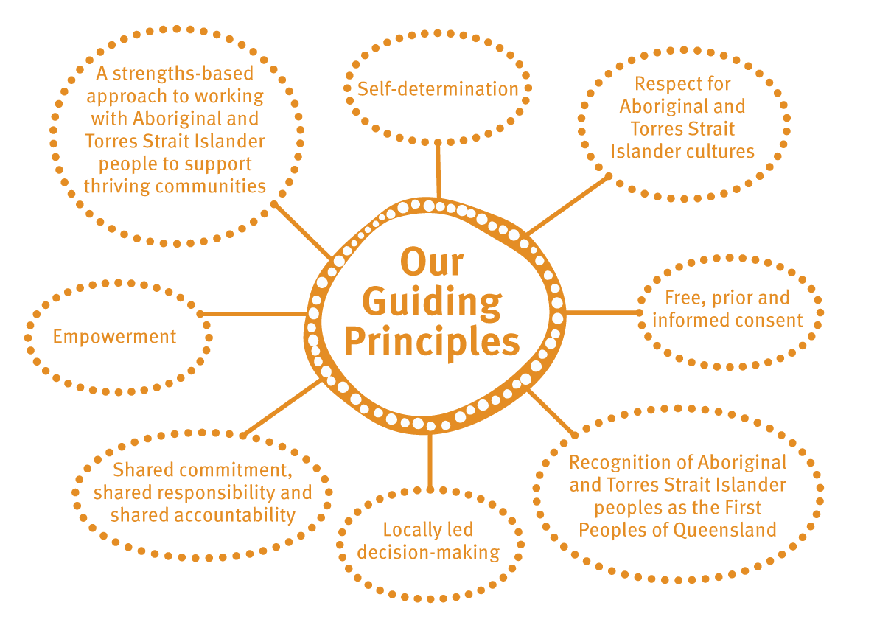

Priority Areas 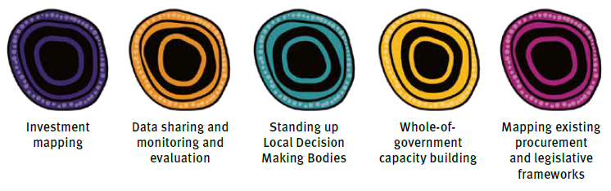

Implementation so far
Local Thriving Communities (LTC) is a long-term iterative reform that adopts a staged approach to implementation. Since 2019, the LTC implementation team has been working to progress whole-of-government and community implementation of the reform. This work has been enabled through support and oversight from LTC governance groups and through consultation with community, Queensland Government agencies and the Australian Government.
In collaboration with key agencies, the LTC implementation team has engaged with each community to determine how LTC could best work for them. The establishment of interim Local Decision Making Bodies to date is a significant step towards bringing decision-making closer to the local level. Each community determines membership and structure of a local group, and this group engages directly with Government and continues to engage with their community.
Alongside LTC implementation, progress has been made by all Queensland Government departments to implement the intent of the reform agenda set out in the QPC Inquiry into Service Delivery in Remote and Discrete Aboriginal and Torres Strait Islander communities. The << QPC Progress Update >> provides further detail about this work.
This work has culminated in the first Action Plan which sets out the steps needed to ensure the Queensland Government continues its transition towards shared decision-making, shared accountability, and shared commitment with LDMBs. To succeed, critical steps are needed including:
- enhancing whole-of-government coordination
- improving Queensland Government cultural capability
- increasing opportunities to share decisions and co-design activities with interim LDMBs
The first Action Plan has been developed to work within existing systems, recognising that much of what is needed is attainable within existing legislative and procurement frameworks.

By the end of 2024
- Local Decision Making Bodies (LDMB) are sharing decisions with government about the design, delivery, and effectiveness of Queensland Government-funded services in remote and discrete communities.
- LDMBs are informed by having access to their community’s data via an online portal. This includes access to community investment profiles aligned with community priorities and other data that respond to local needs.
- Communities have shaped a Local Thriving Communities (LTC) monitoring and evaluation framework that recognises and strives for communities’ vision of what success looks like. Outcomes will be monitored for continuous improvement.
- A community agreement, co-designed and co-signed by Queensland Government Ministerial and Government Champions and the LDMB, set out agreed priorities and commitments.
- Local decision-making is supported by resources that guide community and government in this new way of working, including an integrity framework.
- A community of practice leads whole-of-government capability, knowledge sharing and engagement in culturally capable co-design.
- The Queensland Government’s procurement framework supports Queensland Government departments to engage effectively with LDMBs.

Community perspective of LTC

Aboriginal people and Torres Strait Islander people living in remote and discrete communities are at the heart of the Local Thriving Communities (LTC) reform. Building from recommendations in the QPC Inquiry, the Queensland Government has continued to engage with First Nations peoples, including community leaders and Indigenous Council Mayors, to ensure that progress occurs at community’s pace and that implementation continues to maintain the principles of self-determination and a partnership approach.
Recognising the value of community perspective, the Queensland Government has supported the development of a diagram by First Nations community members of the LTC Joint Coordinating Committee titled “Community Perspective of LTC”. This diagram provides a high-level perspective that requires tailoring for each community in recognition of the unique historical and cultural contexts and local interests.
The Queensland Government cannot succeed in progressing the LTC reform without building its capacity and capability in understanding Aboriginal and Torres Strait Islander communities.
This diagram guides Government’s understanding of the multiple interests within communities and the frameworks that holistically seek to enable self-determination and maintain the rights of First Nations peoples.
The diagram also supports community leaders to consider how the interests from across community might be represented and empowered when establishing a Local Decision Making Body.

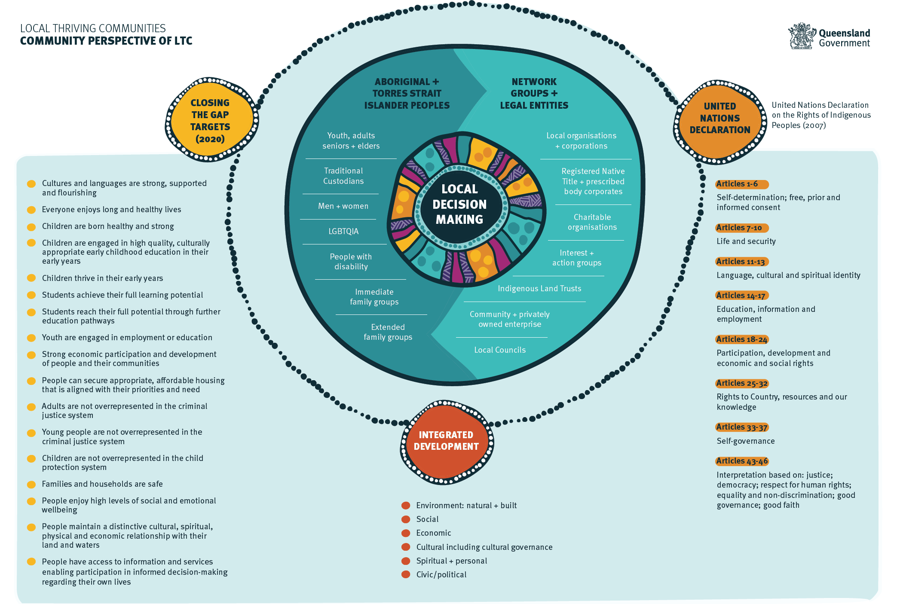

Taking Action – the priority areas
Actions under each priority area outline the short-term activity the Queensland Government has committed to, to effectively support and engage with Local Decision Making Bodies (LDMBs). Focus in 2022-24 will be on progressing the reform within existing mechanisms. Progress will be monitored, and reporting will inform the additional steps needed to effect systemic change.
This Action Plan is delivered through five priority areas:
Priority Area 1 - Investment Mapping
To give communities and government oversight of current investment, maximise future investment and reduce duplication.
Priority Area 2 - Data sharing and monitoring and evaluation
To promote transparency, give communities a comprehensive picture of what is happening in their communities and to co-design monitoring and evaluation frameworks to ensure services are meeting communities’ needs.
Priority Area 3 - Standing up Local Decision Making Bodies
To establish Local Decision Making Bodies that are recognised by community and government, resulting in improved coordination and service delivery in communities.
Priority Area 4 - Whole-of-government capacity building
To build government’s capacity and cultural capability to enable local decision-making, improve engagement and coordination and deliver services that respond to communities’ aspirations.
Priority Area 5 - Mapping existing legislative and procurement frameworks
To embed the reframed relationship in the commissioning cycle, including co-designing services with communities and removing impediments to communities delivering services.

Priority Area 1 - Investment Mapping
Why?

Local decision-making cannot occur without Local Decision Making Bodies (LDMBs) having access to information on the investment coming into their community. Getting a full picture of investment in remote and discrete Aboriginal and Torres Strait Islander communities has been a challenge for government departments and community stakeholders for decades. In its response to the Queensland Productivity Commissions inquiry into Service Delivery in Remote and Discrete Aboriginal and Torres Strait Islander communities report, the Queensland Government committed to putting communities at the centre of service design. Mapping service delivery expenditure is essential to deliver this commitment.
For the Investment Mapping priority government agencies need to work together to identify and share information about existing service delivery investments in an accessible way. This information will assist LDMBs to make informed decisions about the design, delivery, and priorities for investment in service delivery in their community. This includes information about the total amount and period of the investment, whether the service delivery provider is an Indigenous organisation, whether it employs local people from community and how the service is delivered.
The potential benefits of investment mapping are significant, both in terms of enabling self-determination by providing local-level information, and identification of possible savings that could be redirected towards activities that respond to community values and interests. Alongside this work, the LTC implementation team will continue to explore opportunities to further enhance information sharing and data visualisation by working with LDMBs and government agencies to present information on community priorities in accessible and meaningful ways.
Further, LTC implementation supports governments to consider related commitments such as those in the National Agreement on Closing the Gap that encourage greater transparency of information about investment in services and programs to improve outcomes for Aboriginal people and Torres Strait Islander people.
This priority identifies a staged approach towards providing each Aboriginal and Torres Strait Islander community a greater insight and influence on investment and service delivery in their community. Once fully achieved, investment mapping will support LDMBs and government to make smarter decisions about investment, resulting in services achieving better outcomes aligned with community needs.
Benefits of investment mapping
- Reduce overlap and duplication of investment and services in communities.
- Enable LDMBs to be informed by current and accurate information.
- Support policy and decision-makers across government and Aboriginal and Torres Strait Islander communities to make more informed investment decisions.
- Identify gaps in current service delivery and opportunities to redirect investment.
- Guide investment in service delivery which aligns with community needs and priorities.

Actions
Action | Priority Area | Agency Leads
- Investigate, analyse, and incorporate learnings from previous attempts at service mapping and investment mapping. |  | DSDSATSIP  DCHDE, QH, DCYJMA, DoE, DJAG, DES, QPS, QT.
- Undertake comprehensive investment mapping for a community, prioritising communities where an interim LDMB has been established, including a consistent methodology for determining direct, regional, and universal service funding for communities. |  | DSDSATSIP  All Agencies
- Develop community investment profiles for LDMBs, aligned to community priorities. |  | DSDSATSIP  All Agencies
- Progress the Mornington Island service audit and the development of a service investment audit and analysis tool. |  | QH, DSDSATSIP, DPC  All Agencies
- Work with LDMBs to ensure their community investment profile meets their needs. |  | DSDSATSIP  All Agencies
- Work with Government agencies to ensure proactive sharing of investment data that meets community needs and collaborate to overcome barriers as they arise. |  | DSDSATSIP, DCHDE  All Agencies
- Leverage the Intergovernmental Agreement on Data Sharing to support Investment mapping about Australian Government-funded services. |  | DSDSATSIP  All Agencies

Case Study – Mornington Island Audit and Analysis
In April 2021, the Mayor of Mornington Shire Council, Councillor Kyle Yanner, called for an independent audit into services delivered to Mornington Island. The Mayor expressed his concern about the continuing poor life outcomes for Mornington Island residents. This directly aligns with the Queensland Government’s existing commitment to implement the Local Thriving Communities (LTC) reform agenda, which seeks to enhance government coordination and improve the design, delivery and accountability of services delivered in communities.
Mayor Yanner and the Mornington Shire Council discussed the audit with Minister Scanlon (Ministerial Champion), Assistant Minister McCallum (Assistant Ministerial Champion) and Dr John Wakefield (former Government Champion) and together talked about their collective vision, aspirations, and challenges for the community.
Under the direction of the Government Champions, Queensland Health’s Chief Aboriginal and Torres Strait Islander Health Officer and Deputy Director-General, Aboriginal and Torres Strait Islander Health Division, Ms Haylene Grogan and the Department of Seniors, Disability Services and Aboriginal and Torres Strait Islander Partnerships (DSDSATSIP), the Queensland Government has co-designed a project that responds to this community-driven request from Mayor Yanner and the Mornington Shire Council.
The Queensland Government response demonstrates the new way of working being progressed through LTC. The audit aims to facilitate improved outcomes across key community determined building blocks essential for healthy, safe, and thriving communities. These key building blocks include early childhood education, schooling, health, economic development and participation and safe communities.
The audit will provide the Mornington Island community with greater information about investment and services being delivered to their community, aligning with LTC’s key priority actions that will support effective investment mapping.
A key aim of the audit is to increase transparency of government and government funded services delivered to Mornington Island. It will also provide learnings, resources, and a pathway for other First Nations communities and Ministerial and Government Champions to use to support similar initiatives in other First Nations communities through the LTC reform.
This project demonstrates how government can reframe its relationship with First Nations communities and can come together and work in genuine partnership to improve outcomes for Aboriginal people and Torres Strait Islander people.
This whole-of-government initiative led through a cross-agency funded partnership between Queensland Health and DSDSATSIP and supported by the Government Champion Secretariat is to be completed in the second half of 2022. Key learnings and resources produced from this project will be used to enhance Investment Mapping priorities for other communities in line with the LTC reform.

Priority Area 2 - Data Sharing and Monitoring and Evaluation

Why?
This priority area aims to develop processes that allow for accessible data sharing between the Queensland Government and Local Decision Making Bodies (LDMBs) that respond to community priorities.
A building block approach to data sharing, data accessibility and data sovereignty will be undertaken. In the first instance, the Local Thriving Communities (LTC) implementation team will develop processes to share existing data profiles for each community. Government will work with communities to enhance data visualisation to ensure accessibility of meaningful data for communities. The accessibility and sovereignty of the data is an important component of this priority area and as LDMBs mature, Government will be guided by communities to learn and respond to data aspiration requirements.
To measure and monitor the success of local decision making in communities in relation to community priorities and aspirations, the LTC implementation team will develop and co-design a monitoring and evaluation framework. Engagement with interim LDMBs, other community stakeholders and LTC’s Joint Coordinating Committee (JCC) will inform its development.
Evaluation will also inform future program design and allow service providers to adapt the way they deliver services to meet changing and emerging needs of Aboriginal and Torres Strait Islander people in remote and discrete communities. This will also inform future work and reform outcomes that share similar aspirations.
Benefits
- Enable communities to participate as equal partners in decision-making by giving communities access to data.
- Mistakes in service provision are identified and rectified early; lessons learnt can be built into future design and development.
- Services are more accountable to users and community members have greater choice.
- Evaluation can inform program design and help providers deliver services that meet the needs of Aboriginal and Torres Strait Islander people in remote and discrete communities.
- Government, service providers, the private sector and community can work more collaboratively.

Actions
Actions | Priority Area | Agency Leads
- Share existing data specific to each community to support local decision-making. |  | QGSO and DSDSATSIP  All Agencies
- Create a data sharing portal to provide LDMBs access to data and facilitate alignment with the investment mapping work and related data sharing initiatives such as those being progressed through implementation of the National Agreement on Closing the Gap. |  | DCHDE (Queensland Government Customer and Digital Group), QGSO and DSDSATSIP  All Agencies
- Be guided by LDMBs to support and understand their aspirations in relation to data that enables local decision-making. |  | DSDSATSIP, QGSO and DCHDE (Queensland Government Customer and Digital Group), DSDILGP  All Agencies
- Co-design a Monitoring and Evaluation Framework to monitor the impact of local decision-making on community outcomes. |  | DSDSATSIP  QH, DCHDE, DJAG, DES, QPS, DoE, DPC, QT

Case Study – Sharing the Statshot Community Profile Report
Communities have long requested access to Queensland Government data. The Queensland Government Statisticians Office (QGSO) compiles a Statshot Community report that includes community level data compiled from the Queensland and Australian Government. The Department of Seniors, Disability Services and Aboriginal and Torres Strait Islander Partnerships and QGSO have recently established a process to share the Statshot with community leaders for the purpose of improving the design and delivery of services.
The Statshot will provide communities with the same detailed, community-level data that government officers use to support the ongoing monitoring and planning of services for Aboriginal and Torres Strait Islander remote and discrete communities.
Sharing this information directly with communities aligns with data sharing commitments made by the Queensland Government through Local Thriving Communities (LTC) and the National Agreement on Closing the Gap. These initiatives aim to enhance data sharing, provide greater transparency and accountability and support community leaders with a more comprehensive picture of what is happening in their community.
Next steps include working with communities to better improve data sharing processes by understanding community needs and aspirations for data accessibility, data visualisation, data sovereignty and opportunities for creating new data. A priority is to continue to listen and work with community leaders and data experts across the Queensland and Australian Governments to build opportunities for communities to make decisions about the design and delivery of services that are informed by current, accessible, and relevant data.

Priority Area 3 - Standing up Local Decision Making Bodies

Why?
The Queensland Government has a role in ensuring that local leaders are supported and enabled to establish a Local Decision Making Body (LDMB) that meets the needs of community. Some communities are opting to progress an existing leadership group, others are starting with an Advisory Committee to the Indigenous Council while others are opting to establish a new group of community leaders. In all cases, the LTC reform encourages empowering the LDMB, and to being inclusive and truly whole-of-community. The ‘Community Perspective of LTC’ diagram developed by the JCC (page 13) can be a useful tool to support these efforts.
The establishment of LDMBs will be supported by the Pathway to Local Decision Making tool (see addendum) which guides work with communities to sign a Statement of Intent and enter into a Community Agreement to formalise the LDMB.
Specifically, Ministerial and Government Champions, supported by the Department of Seniors, Disability Services and Aboriginal and Torres Strait Islander Partnerships and other relevant agencies, will work with their community’s interim LDMB to progress the Community Agreement. The Agreement will detail how the Queensland Government and community leadership will work together to improve service design and delivery. It will detail the agreed priorities, service outcomes, provide formal recognition of the LDMB and commitments from the parties. The Community Agreement will ensure support for community engagement and participation in developing community’s agreed aspirations
The actions below detail how the Queensland Government will enable the <<Pathway to Local Decision Making>> and support government and communities to work in a mutual high expectations relationship. This means that everyone engaged in this process respects and values each other, commits to strive for excellence, and holds each other accountable for their actions. It also ensures Queensland Government commitments, such as compatibility with protected rights under the Human Rights Act 2019 and value for money investment under the Financial Accountability Act 2009, would be maintained under LTC local decision-making processes.
Progress of these actions will support related initiatives that are progressing and enabling First Nations leadership to have a greater voice in Government decision making, such as building capacity to be ready to negotiate treaties. Through monitoring and reporting on progress of these actions LTC will enhance opportunities for coordination and progress of these related priorities.

Benefits
- LDMBs will have the agency and authority to make decisions on behalf of their community.
- LDMBs will work with government to co-design government service delivery to meet community need.
- LDMBs will influence and make recommendations about government investment in community.
- LDMBs will determine how they work in partnership with other community leadership groups.
- Community Agreements recognise the role and authority of LDMBs, giving them the agency to engage on behalf of communities.

Actions
Actions | Priority Area | Agency Leads
- Develop practice guidelines that can be flexibly applied to guide LDMB establishment, including consideration of cultural governance, accountability to community about decision making and principles of engagement with government. |  | DSDSATSIP, DoE, DSDILGP, DJAG
- Develop integrity principles to facilitate effective management of probity and conflict of interest matters as community leaders and government progress on the Pathway to Local Decision Making.  - Develop an integrity framework to support LDMBs with managing issues relating to conflicts of interest, probity, roles, and responsibilities.  - Develop resources from the practice guidelines, integrity principles and integrity framework to support community leaders with local decision-making processes, such as:  - procedures  - checklists  - placemats |  | DSDSATSIP and DSDILGP (Local Government)
- Develop procedures that support Queensland Government agencies when working with LDMBs. Topics include:  - remuneration arrangements for community representatives  - capacity building  - administrative support  - reporting arrangements. |  | DSDSATSIP, DSDILGP (Local Government) DCHDE, DJAG
- Agencies to provide regular reporting to the Joint Coordinating Committee (JCC) and Directors-General Sub-Committee (DGSC) on what they have done to engage with and support local decision making. |  | All agencies
- Develop a template of a Community Agreement that outlines overall commitments of both the Queensland Government and the community, with more specific commitments to be developed in each community’s agreement. |  | DSDSATSIP

Actions | Priority Area | Agency Leads
- Once the LDMB is established, use the Community Agreement template to co-design a Community Agreement with community which sets out commitments and accountabilities for government and the LDMB, to be signed by the Ministerial and Government Champions and the LDMB. |  | Ministerial and Government Champion for each community, DSDSATSIP
- Provide training and mentoring opportunities that support skills development and capacity building of LDMB members, including opportunities for all LDMBs to come together and share experiences with local decision-making. |  | DESBT, DSDILGP, DSDSATSIP, DJAG  DTIS (entrepreneurship policy)
- Work with LDMBs and other local established leadership groups to support effective process to link in with other local leadership groups that have been established as part of Queensland Government-led processes, e.g., Department of Education’s Local Community Engagement through Co-design. |  | DSDSATSIP, DoE  All agencies

Case Study – Mapoon Interim Local Decision Making Body
On 30 April 2021, the Mapoon Aboriginal Shire Council formed an interim Local Decision Making Body (LDMB), giving local representatives a greater voice in decisions affecting their community. After developing and endorsing a Terms of Reference, the Council put a call out to the community for expressions of interest to join the group. Five successful applicants joined the Mayor and Deputy Mayor as inaugural members.
Member Pauline Smith describes the establishment of the advisory group, “It allows us to…oversee every program that comes to the community. We are out there in the community and can see what is happening. It could mean getting men’s and women’s groups re-established…People look up to the members, people come to me and trust me to speak on their behalf.”
Mapoon’s Mayor, Councillor Aileen Addo, also sees the formation of the group as a positive step forward. Mayor Addo has noted the benefits of sharing decisions with community leaders with diverse expertise from across community as this improves the opportunity to listen and understand different perspectives and provides an opportunity for others in Mapoon to benefit from capacity building, including in leadership and governance “we also appreciate members bringing various issues to the meetings and the opportunity for Council and community to be on the same page.” Councillor Addo said.
Direct engagement with government
In November 2021, the Department of Communities, Housing and Digital Economy (DCHDE) met with the Mapoon Aboriginal Shire Council Interim Local Thriving Communities Advisory Committee (Interim LDMB). This format provided a new opportunity to discuss housing related matters and gain the LDMB’s view on current service provision to identify opportunities for service reform. DCHDE was keen to discuss opportunities in the Aboriginal and Torres Strait Islander Housing Action Plan 2019–2023, which represents substantial investment to continue community-led solutions and co-design of community housing. These efforts continue a focus on reframing the relationship with First Nations peoples through genuine partnerships between Government, communities and the housing sector to create housing outcomes that enable self-determination. Discussions focused on tenancy and property management, new construction, and community home ownership aspirations in Mapoon.
In remote and discrete communities, the Housing Action Plan is being delivered in line with the LTC reform to co-design and deliver structural, service delivery, and economic reforms.
Engaging directly with the Interim LDMB in Mapoon about their Local Housing Plan has enhanced the design and delivery of DCHDE’s support for housing in Mapoon and brought fresh perspectives and enthusiasm to the discussion. Through the Interim LDMB, DCHDE was able to engage with a range of community-leaders, as determined by community, and had confidence that the advice provided was representative of broad community voice. DCHDE will continue to engage directly with Mapoon’s Interim LDMB and others, as they emerge.

Priority Area 4 - Whole-of-government capacity building

Why?
Change needs to happen within the Queensland Government so that systems, processes, and practices enable
self-determination and public servants are supported and equipped to engage effectively with local decision making. Whole-of-government cultural and operational capacity will be built through a “learn by doing” iterative approach, recognising that the transitional change needed for Local Thriving Communities to succeed requires navigation of multiple complexities within Government as well as with communities.
Over the next two years the LTC implementation team will develop a mechanism to capture and share lessons learned across government in relation to co-design, place-based programs and enabling local decision making with interim Local Decision Making Bodies (LDMBs), LDMBs and communities. Greater transparency will support operational and cultural capacity building within the Queensland Government.
This priority will also support agencies to identify gaps and opportunities to share or hand over decision-making to communities, recognising that much of what this priority area seeks to achieve is workable within existing frameworks. Actions set out in this section are intended to improve whole-of-government coordination and engagement with communities to ensure genuine partnerships between government and communities are established and embedded into Queensland Government service delivery system.
There is significant work being progressed across the Queensland Government that seeks to transition systems, processes, and practices towards enabling self-determination, including:
- Our Way Strategy - A generational strategy for Aboriginal and Torres Strait Islander children and families 2017-2037
- Making Tracks Together: Health equity framework and the Aboriginal and Torres Strait Islander Health Division
- Path to Treaty Office – specifically the Government Treaty Readiness Committee with the purpose to prepare agencies to build their capacity to be treaty ready.
- Queensland Government Reconciliation Action Plan 2018 – 2021
- Cultural Agency Leaders Committee
- Certificate IV in Cultural Capability training provided to Queensland Government staff
- Queensland's 2021 Closing the Gap Implementation Plan
- The Aboriginal and Torres Strait Islander Housing Action Plan 2019 - 2023
- The Gurra Gurra Framework 2020-2026
- The Ministerial and Government Champions program.
The LTC reform seeks to streamline efforts so that the Queensland Government is collectively identifying and addressing operational capability gaps and supporting public servants to have the necessary skills, knowledge, and processes in place to support local decision making.

Benefits
- Coordinated approaches to co-design with LDMBs
- Public servants with cultural and operational capability can better respond to community needs
- People-focused engagement with individuals, service providers and communities
- Programs and services are delivered in a more coordinated way, with services meeting the needs of communities.

Actions
Actions | Priority Area | Agency Leads
- Support existing cultural capability building mechanisms, including the Queensland Government Reconciliation Action Plan, Certificate IV in Cultural Capability, and the Cultural Agency Leaders Committee. |  | Ministerial and Government Champion for each community, DSDSATSIP
- Agencies identify opportunities to share decisions with LDMBs and engage in local decision-making. |  | All agencies
- Establish a community of practice in co-design to:  - coordinate agency-led co-design projects; and  - support shared co-design practice and knowledge across government. |  | PSC and DSDSATSIP  (i) DSDSATSIP  (ii) PSC  All agencies with co-design projects
- Develop internal data sharing so that lessons (successes and failures) from initiatives that empower community-led decision-making and drive efficiency in service delivery can be shared and built on (e.g., community of practice). |  | DSDSATSIP

Case Study – Local decision making in Queensland Public Service recruitment
The Queensland Government has funded a place-based project in Yarrabah focused on prevention and early intervention activities for young people – the Yarrabah Positive and Respectful Relationships project. The aim of the project is to promote respectful relationships, strengthen young people’s safety and prevent sexual and family violence.
The project is a joint initiative of the Department of Justice and Attorney-General (DJAG) and the Department of Seniors, Disability Services and Aboriginal and Torres Strait Islander Partnerships (DSDSATSIP). The project involves working closely with the local community, young people, elders, parents, caregivers, stakeholders, and clinical experts to co-design prevention strategies based on local needs and priorities. The project is supported by a Principal Project Officer position which plays a critical role liaising between government and community. Appointing someone to this role who is welcomed by community is critical; not only does the candidate need to have the technical abilities to undertake government’s requirements, they need to have skills in cultural capability, local knowledge and to be able to establish and build relationships with local people, in line with the Queensland Government’s Statement of Commitment.
Recognising that this latter selection criteria cannot be judged effectively by departmental officers based in Cairns or Brisbane, the Queensland Government recognised an opportunity to work with local leaders from the community to assess applicants’ suitability for this role. DSDSATSIP established a process where Yarrabah community leaders were invited to lead the recruitment process to ensure the Principal Project Officer had the right mix of skills for success for this place-based project including cultural safety, local knowledge and building positive relationships with the Yarrabah community.
After the position was advertised externally through normal recruitment channels, DSDSATSIP worked with Yarrabah community leaders to establish a local selection and recruitment panel, made up of respected local leaders, to design the recruitment strategy and ensure a suitable candidate was selected. A community leader, DSDSATSIP and DJAG progressed initial shortlisting of candidates and then handed the final recruitment process over to the Yarrabah leaders for the interview and selection process.
The Queensland Government and the Yarrabah community can be confident that the successfully appointed candidate for this role has both the technical abilities, including cultural capability, and that they are welcomed by Yarrabah’s community leaders to build relationships with the community to progress the Yarrabah Positive and Respectful Relationships project.
Ruth Fagan, a Yarrabah community leader who sat on the recruitment panel said “it goes without saying that having local input and decision-making when recruiting positions in community will influence outcomes, so this new way of business is exciting and further to this was the knowledge exchanges and shared understandings that occurred throughout the process. This model has the capacity to tap into community experts (not just local leaders) appropriate to the position working side by side with government departments to recruit the best possible candidate. It may take a little more time but the return on investment will be significant.”
This recruitment process is an important example of including community voice at the initial states of program design within existing frameworks, to ensure services are delivered in a culturally safe way.
The process was replicated for a recent Program Director position in DSDSATSIP where a Council Mayor, a Council Chief Executive Officer and a Community Controlled Health Organisation Chief Executive Officer formed a selection panel and undertook the recruitment process, supported by DSDSATSIP.

Priority Area 5 - Mapping existing legislative and procurement frameworks

Why?
Queensland Government agencies are becoming more proactive in engaging with communities when procuring services in remote and discrete communities however further opportunities have been identified through engagement with procurement and commissioning experts across the Queensland Government and First Nations community leaders. This priority area will build on existing activity to embed the reframed relationship within the procurement and commissioning cycle.
The purpose of this priority area is to support the Queensland Government to invest in service delivery models that suit local circumstances, remove impediments to Indigenous service delivery, businesses being supported to provide local services and enhancing user-choice by placing people at the centre of service delivery. This will maximise investment in communities and ensure decisions about service design and delivery are responsive to the needs of local Aboriginal and Torres Strait Islander people. This involves ensuring community voice at all stages of the procurement cycle from program design and delivery to ongoing management and evaluation.
Complimentary authorising environments such as legislation, whole-of-government policy and/or directives will be monitored to ensure the Queensland Government is equipped to engage in, and support, effective local decision making by sharing decisions, accountability, and commitment with interim Local Decision Making Bodies (LDMBs) and LDMBs, once formalised.

LDMBs will be established and operate with regard to legislative frameworks including compliance with the Human Rights Act 2019 (Qld).
Benefits
- LDMBs engage in procurement to co-design services within existing legislation and policy.
- LDMBs receive support to build capacity to engage with government.
- Services are responsive to the needs of Aboriginal and Torres Strait Islander people and communities.
- Government can make smarter investment decisions through enhanced knowledge about how best to respond to local needs and aspirations.
- Legislation can be coordinated in more comprehensive manner to support community decision-making needs.

Actions
Actions | Priority Area | Agency Leads
- Embed engagement processes with LDMBs in procurement planning, evaluation processes and contracts with Queensland Government agencies delivering services in remote and discrete communities through the Social Services Category Council and Working Groups. |  | Social Services Category Council, DCYJMA (Child Safety), DCHDE (Social Services Category Council), DJAG, DSDSATSIP, QH, DEPW
- Update and develop tools for procurement and commissioning officers (and other staff) to facilitate processes within government procurement that enable government engagement with LDMBs. |  | DSDSATSIP (CEP, LTC), DCYJMA (Child Safety), DCHDE (Social Services Category Council), DTMR
- Procurement officers across government agencies to complete training in cultural capability. |  | All agencies  DTMR, DCHDE, DoE, QCS, QH, DJAG, DSDILGP, DTIS DCYJMA
- Determine procurement processes that can work for each of the emerging LDMB models, including:  - Advisory Committee to Council (s264, Local Government Regulation 2012)  - leveraging an existing leadership group  - formation of a new decision-making entity. |  | DSDATSIP and DSDILGP, QT
- Explore opportunities through the Queensland Indigenous (Aboriginal and Torres Strait Islander) Procurement Policy (QIPP) for Aboriginal and Torres Strait Islander leadership bodies to maximise potential local procurement outcomes. |  | DSDSATSIP
- Determine opportunities and limitations of existing legislative frameworks to:  - ensure decision making processes include LDMBs and the authority of local decision-making in the design, delivery and evaluation of programs and policies  - enable the functions of LDMBs  - assess the need for specific amendments or new legislation to enshrine authority of LDMBs |  | DSDSATSIP

Case Study – Safer, Stronger Yarrabah
Social reinvestment encourages communities to identify a matter they want to address and implement local actions to address the issue. It is a key part of the Queensland Government’s Investment Reform supporting co-designed projects, developed in collaboration with communities. This aims to achieve and track progress on mutually agreed performance milestones and indicators, leading to improved and sustained outcomes.
Through an expression of interest process, the LTC team sought applications from remote and discrete Aboriginal and Torres Strait Islander communities. Yarrabah Aboriginal Shire Council was the successful recipient of an LTC social reinvestment grant of $150,000 to address domestic and family violence in partnership with local services in their community.
Yarrabah Aboriginal Shire Council’s proposal was to work through the local leadership group, Yarrabah Leaders Forum (YLF), to address the underlying causes of domestic and family violence through the delivery of initiatives that build resilience, foster connections, and strengthen community and cultural values. The assessment panel agreed that this approach will build a strong foundation for future community development. The YLF is a group of local leaders with a shared vision represented by a six-pillar model to address issues locally and within community and cultural frameworks through better data sharing, communication, and increased resourcing at the local level. Yarrabah Aboriginal Shire Council is working with local service providers through the YLF including Gurriny Yealamucka Health Services and government agencies.
This social reinvestment initiative in Yarrabah is a clear example of how the LTC reform is committed to supporting local decision making and community-led-service delivery that addresses community-led solutions and respond to the needs and priorities of community. It is also an example of reframing funding processes to support longer-term developmental objectives and funding for outcomes.

Local Thriving Communities Governance
Progress of activity outlined in the Local Thriving Communities (LTC) Action Plan will be overseen by LTC’s governance bodies. Queensland Government departments will be asked to report on progress of actions on an annual basis and this information will be tabled annually at LTC governance body meetings.
LTC’s governance bodies include the Joint Coordinating Committee, Directors-General Sub-Committee, and Interdepartmental Committee. This governance structure was established in the early phase of LTC implementation to ensure that the reform can be informed by the perspective of all levels of Government and community leaders. LTC governance champions the Reframed Relationship between the Queensland Government and Aboriginal and Torres Strait Islander communities and demonstrates the benefits of shared decision making, shared-accountability and shared-commitment.
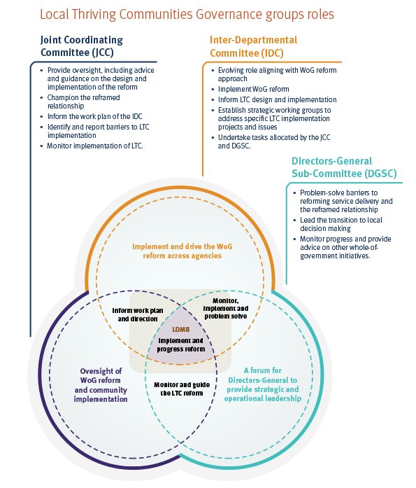

Joint Coordinating Committee
The Local Thriving Communities (LTC) reform is overseen by a Joint Coordinating Committee (JCC) demonstrates the value of all three levels of government working collaboratively with community leaders. The JCC is co-chaired by the Director-General, Department of Seniors, Disability Services and Aboriginal and Torres Strait Islander Partnerships, and a community member. The co-chairs share decisions about forward meeting agenda priorities, meeting papers, capacity building opportunities for the group and meeting dates and locations. Community members elected to have this leadership role is shared resulting in each community member taking co-chair leadership of the JCC on a rotational basis for three meetings each.
JCC membership comprises six senior representatives from First Nations communities, five mayoral representatives nominated by the Local Government Association of Queensland Indigenous Leaders Forum and senior representatives from 11 Queensland and Australian Government departments, including the National Indigenous Australians Agency and Queensland service delivery agencies, as equal partners. Further information, including current membership, is available on the JCC webpage.
The JCC oversees and directs progress of the LTC reform agenda and provides strategic advice to the Directors-General Subcommittee, Ministerial and Government Champions and the Minister for Aboriginal and Torres Strait Islander Partnerships.
Directors-General Subcommittee
The Directors-General Sub-Committee (DGSC) champions the LTC reform, leading improvements to whole-of-government coordination and leading the commitment to a Reframed Relationship within members’ agencies.
The DGSC is a strategic and operational whole-of-government committee tasked with improving the economic and social wellbeing of Aboriginal people and Torres Strait Islander people and to ensure service delivery is fit-for-purpose. The DGSC monitors progress and provides advice on the progress of LTC, the Ministerial and Government Champions Program, the National Agreement on Closing the Gap and the Remote Indigenous Land and Infrastructure Program Office.
Interdepartmental Committee
The Interdepartmental Committee is an officer-level working group that implements the whole-of-government reform across Queensland Government, as directed by the JCC and DGSC.
Local Decision Making Bodies
Once established, Local Decision Making Bodies (LDMB) will play a central role in determining how LTC implementation is progressed with each community and on the design and delivery of services in the community. Government has a role to play in ensuring communities have the necessary support and capacity building opportunities, as determined by community, to be empowered to engage directly with the Queensland Government.
LDMBs will be the central point of engagement with community, including to inform related initiatives such as the National Agreement on Closing the Gap and the co-design to inform the Indigenous Voice process.

Addendum: Pathway to Local Decision Making
The Pathway to Local Decision Making provides each community with the opportunity to define and determine how they want to engage with Local Thriving Communities (LTC).
The pathway illustrates the steps underpinning the reframed relationship between the community and government.
LTC does not replace existing decision-making structures. Rather, councils and existing leadership groups are at the forefront of the co-design process and are involved in informing the place-based approach to local decision making
